**Cost of Living Index**

1. I downloaded the file from GitHub
2. I opened Jupyter Notebook
   1. I imported Pandas
   2. I created the file path
   3. I created a new data frame with only the columns we needed
   4. I used .find to find cities located in the U.S.
   5. I took out all cities not located in the U.S.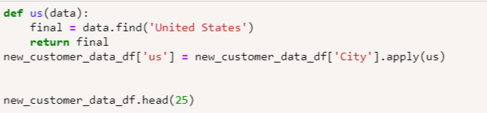
   6. I saved the new data frame as a csv
3. Added the csv to the database
   1. Created a new table
   2. Added each column
   3. Imported the new csv

**Pizza Restaurants**

1. Downloaded csv from Kaggle
   1. Opened it in excel
   2. Removed columns that referenced currency type, since all the data was for the USA
   3. Removed columns that referenced country
   4. Removed a column with multiple categories separated by columns within each cell to prevent confusion when loaded to a database
   5. Removed “keys” column which listed all of the collected location data in one cell separated by the “\” key
2. Created jupyter notebook
   1. I imported pandas
   2. Read in the pizza csv as a dataframe
   3. Wrote it as a new csv with an index
3. Created a database
   1. Added the table for the pizza data
   2. Added each column and set their data types
   3. Imported the new csv